**Installation**:

<https://biop.github.io/ijp-imagetoatlas/installation.html>

Note: If you update either QuPath or Fiji → you will lose some functionality from ABBA! If you need any help you can contact Rodrigo.

**Using ABBA**:

MAKING A QUPATH PROJECT

1. Create an empty folder anywhere you’d like.
2. Open QuPath, click on “Create project” under the Project tab, open the empty folder you just created.
3. This will create several folders and a “*.qppoj” that references any changes made to this project.
4. Upload images to the project (supported image types: <https://qupath.readthedocs.io/en/stable/docs/intro/formats.html> ) by clicking “Add Images” or by dragging the images.
   1. Set the image type and choose if you want to rotate the images. You can leave the “Image provider” to “Default”.

USING THE ABBA (Allen Brain BIOP Aligner) PLUGIN

1. Now go to Fiji > Plugins > BIOP > Atlas > ABBA
   1. If after installation Fiji asks you to update, say no or “Remind me later”.
2. A widget will pop up asking if you want to change path file names for the map and ontology data and elastix and transformix files, it is only necessary to have the last two file paths filled > Press OK
3. Choose your slicing mode
4. A row of slices will appear, give it some time to render.
5. Go to Import > Import QuPath project and select the “*.qppoj” of your designated project.
   1. Insert initial axis position (relative to bregma?)
   2. Insert axis increment between slices
   3. Then advanced setting will appear , if “Usebioformatscacheblocksize” is unchecked, check it, leave everything the same.
6. This will open your brain slices that should look like this:

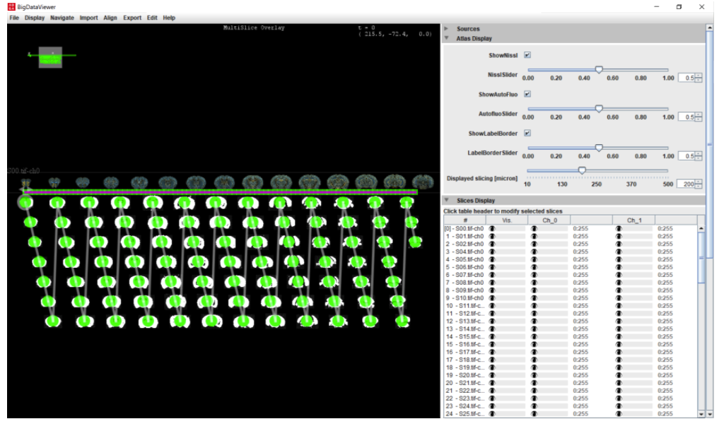

1. You can adjust the coloring of the brain slices by clicking the white bar above the color columns.
   1. I suggest just replacing the original blue color they give you to the darkest blue there is in the pallet for fluorescence images.
   2. Note: Make sure all slides are selected to make macro changes, else, just do changes one by one.
2. You can deselect channels 0 and 1 for the atlas display if you’re only focused on aligning your slices with the borders of the atlas.

SLICE-ATLAS REGISTRATION

1. Select all slices, Align > Elastix Registration (Spline)
   1. Atlas channels: 0 (Nissl)
   2. Slices channels: 1 (green gives the best results (unfortunately, multichannel registration isn’t possible)).
   3. “Number of control points…” : 20 (seems to be the sweet spot, too few or too many points can skew the alignment accuracy.
   4. Other parameters: leave as default.
2. You can press “R” to view the atlas and slice as an overlaid image. Registration is finished when all circles are green.

MANUAL REGISTRATION

Most likely, you will need to adjust the automatic alignment that’s been done. For this, here are the following steps:

1. Select an image to manually register
2. Right click > Edit last registration > You can have atlas channels as “2” and slices as “*”.
3. 2 windows will appear, on the fixed image window, press Space to activate Landmark mode and start dragging the landmarks to adjust your slice’s fit for the atlas borders.
   1. Note: if you accidentally create a new landmark, you can simply delete it by scrolling down the landmarks and right click > delete
4. Once you are done, press space.
   1. Note: If you mess up the manual registration, you press OK and on the selected slice > Remove last registration

EXPORT ALIGNMENT RESULTS

1. Select all brain slices > Export > Export Regions to QuPath project.
   1. You can delete previous ROIs
2. Done when all the boxes are green.
3. Go back to QuPath > Automate > Show script editor.

AUTOMATING CELL DETECTION

1. Ask Rodrigo to send you the automation script.
2. Once you have the script, open it in through the script editor
3. You will need to change lines 53 and 63 for your use case. 53 is where you select the parameters for cell detection. 63 is selecting what folder you want your results, per slice, to be stored in.

ADJUSTING CELL DETECTION PARAMETERS

| **These are the parameters you may be interested in changing (Positive Cell Detection)**  Setup parameters   1. Detection channel    1. DAPI (blue)- binds strongly to AT rich regions in DNA of any cell, it can pass through intact cell membranes (stains live and fixed cells). This is due to the fact that DAPI is a conjugated system that needs less energy to produce fluorescence.    2. FITC (green) - conjugated with antibodies and proteins (Cre?) for cellular imaging applications    3. TRITC (bright orange) - conjugated with antibodies and proteins (Cre?) for cellular imaging applications 2. Requested pixel size    1. Pixel size at which detection will be performed - higher values are likely to be faster but less accurate, set <= 0 to use full image resolution   Nucleus parameters   1. Background radius - the area in which to subtract from the cell of interest 2. Median filter radius - to reduce image texture 3. Sigma - to reduce noise, increasing it stops nuclei from being fragmented, but may reduce accuracy of boundaries 4. Minimum area - min area of nuclei 5. Maximum area - max area of nuclei 6. Threshold - threshold for brightfield 7. Watershed post process - ignore 8. Cell expansion - ignore, only if your detecting nuclei 9. Include nuclei - only include if your focused on nuclei 10. Smooth Boundaries - smooth out the boundaries 11. Make Measurements - to see the boundaries clearly 12. Threshold compartment - if focused on cytoplasm, choose cytoplasm, choosing mean means the staining should be done for the entire cell, where max means staining should be found somewhere in the cell compartment 13. thresholdPositive1-ignore 14. thresholdPositive2-ignore 15. thresholdPositive3-ignore 16. singleThreshold-ignore |
| --- |

**Change the parameters (delete old parameters) to your liking and copy and paste to replace line 53:**

runPlugin('qupath.imagej.detect.cells.PositiveCellDetection', imageData, '{"detectionImage": "FITC", "requestedPixelSizeMicrons": 0, "backgroundRadiusMicrons": 10.0, "medianRadiusMicrons": 0.0, "sigmaMicrons": 2.0, "minAreaMicrons": 55.0, "maxAreaMicrons": 400.0, "threshold": 15.0, "watershedPostProcess": true, "cellExpansionMicrons": 0.0, "includeNuclei": false, "smoothBoundaries": true, "makeMeasurements": true, "thresholdCompartment": "Cytoplasm: FITC mean", "thresholdPositive1": 100.0, "thresholdPositive2": 200.0, "thresholdPositive3": 300.0, "singleThreshold": true}');

1. Once you are done changing line 53 and 63, press Run > Run to run the script.
2. For the end product you should have the visual results for the alignment and cell counts per region for each slice in your QuPath project and CSV files that correspond to each image in the project containing information on cells and number of cells.

Done!

Parameter test trials:

CHOSEN PARAMETERS: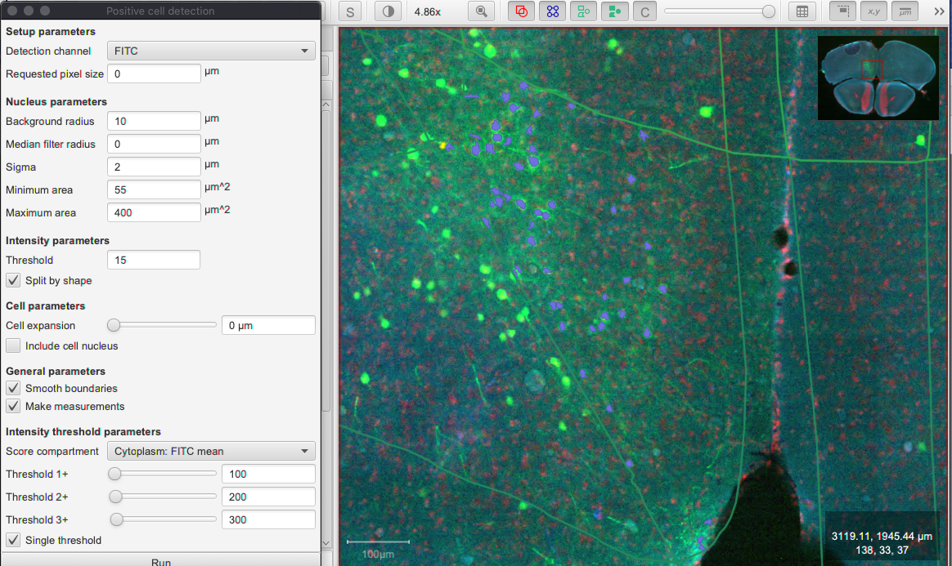

Note: The algorithm for cell detection will never be perfect, so to remove cells that are not cells:

Write down the centroid X um of each cell and let me know so I can send you an automated script that removes those cells in the corresponding CSV file. (if there are cells that weren’t detected, decrease the threshold slightly (you’ll add in more false positives but at least you’ll have all the cells included).

=========================IGNORE========================================

Problem: the parameters are good for that one region I tested, but if u test the entire brain slice, it's so bad, increase the threshold

1. runPlugin('qupath.imagej.detect.cells.PositiveCellDetection', imageData, '{"detectionImage": "FITC", "requestedPixelSizeMicrons": 0, "backgroundRadiusMicrons": 10.0, "medianRadiusMicrons": 0.0, "sigmaMicrons": 2.0, "minAreaMicrons": 55.0, "maxAreaMicrons": 400.0, "threshold": 15.0, "watershedPostProcess": true, "cellExpansionMicrons": 0.0, "includeNuclei": false, "smoothBoundaries": true, "makeMeasurements": true, "thresholdCompartment": "Cytoplasm: FITC mean", "thresholdPositive1": 5.0, "thresholdPositive2": 10.0, "thresholdPositive3": 15.0, "singleThreshold": true}');